National University of Computer and Emerging Sciences
Peshawar Campus
Programming Fundamentenls
Exercise-01

Submitted By
Name: Sahil Anwar
Roll Number: 22P-9141

Submitted To
Sir Usman

Problem 01
C program to print your name, roll number & section in separate lines.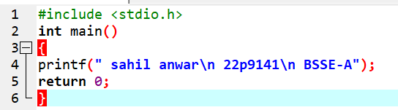

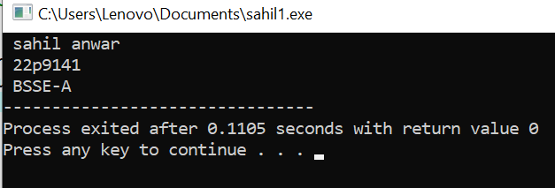

PROBLEM 02
C program to print different patterns.
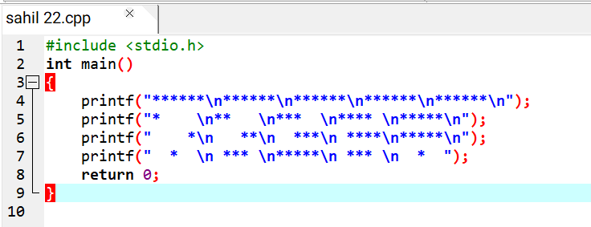

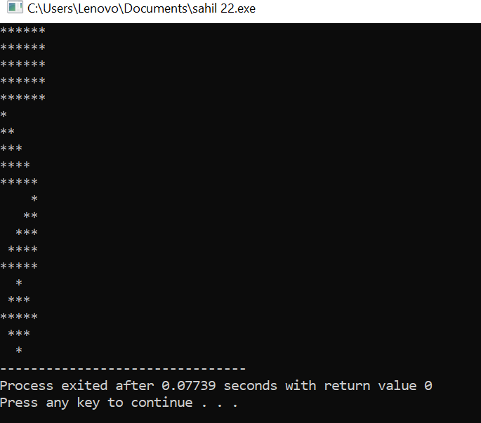

PROBLEM 03
C program to find the area of the rectangle.
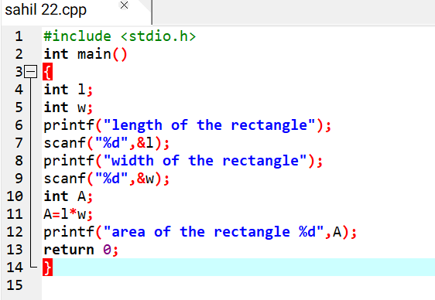

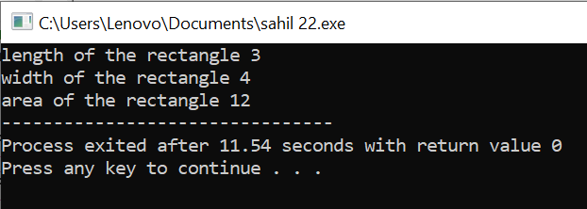

PROBLEM 04
C program to find the volume of the parallelepiped.
